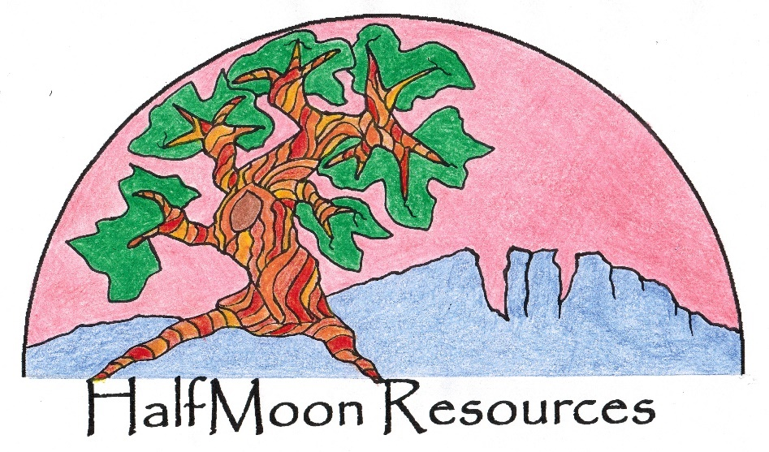

**HalfMoon Resources For Sale**

Owner needs to retire

Reasonable price

**DUI and Drug and Alcohol Treatment Agency - Established 2004**

* State Licensed Substance Use Disorder Treatment Provider
* Groups include Level I Education open to both men and women
* Level II Education and Therapy/Adult Life Skills for women
* Private Counseling and Drug Alcohol Evaluations
* Reputation for creating a safe environment for women
* No marketing needed
* Approved policies and training included in the sale price
* Agency can be relocated anywhere in Colorado
* Currently all groups are state approved to be on-line indefinitely
* **Work at home.** No facility overhead. Can change the Name.

Adding men’s groups would triple the business.

Call for current valuation and price negotiation.

Rose Moon 1-970-412- 4998

*All Classes Online*

Ft. Collins, Colorado

1-970-412-*4998*